Study group 5 assignment 3

Here we present an analysis of the social conformity experiment from (<https://pubmed.ncbi.nlm.nih.gov/30700729/>) where participants rate the trust worthiness of faces on a rating scale from 1 to 8 (first rating). After this initial rating participants then got a group rating which was either their own rating or 2 or 3 rating points above or below (group rating).

After going through this procedure for 80 trials of different faces, participants where then reintroduced to the same faces and had to rate them a second time (second rating).

We here present two computational models that describe two approaches to how people generate their first and second rating in the experiment. The first model we call the simple bayes model, which in essence states that participants generate their first rating based on bias and precision and they then weigh this first rating evenly with the group rating, which generates the second rating. This formulation of the first rating being generated by a bias ensures that the model accounts for the fact that some participants generally might rate higher or lower and with less or more precision.

This means that the first rating is generated from a beta-distribution with a mean (bias) and a precision parameter (kappa), this value is then multiplied by 7 and 1 is added to get the right rating scale of [1;8]. The second rating is then generated by another beta-distribution eq2.

𝑅𝑎𝑡𝑖𝑛𝑔1 ~ 𝐵𝑒𝑡𝑎(𝐵𝑖𝑎𝑠, 𝐾𝑎𝑝𝑝𝑎)

𝑅𝑎𝑡𝑖𝑛𝑔2 ~ 𝐵𝑒𝑡𝑎(𝜇, 𝐾𝑎𝑝𝑝𝑎2)

Where:

𝜇 = 𝑖𝑛𝑣_𝑙𝑜𝑔𝑖𝑡(0.5 ∗ 𝑙𝑜𝑔𝑖𝑡(𝑅𝑎𝑡𝑖𝑛𝑔1) + 0.5 ∗ 𝑙𝑜𝑔𝑖𝑡_𝑠𝑐𝑎𝑙𝑒𝑑(

𝑔𝑟𝑜𝑢𝑝

))

9

Our next model we called the weighted bayes which is a generalization of the simple bayes presented above. Here we put parameters w1 and w2 on the two sources of information instead of weighing them equally with 0.5.

𝑅𝑎𝑡𝑖𝑛𝑔1 ~ 𝐵𝑒𝑡𝑎(𝐵𝑖𝑎𝑠, 𝐾𝑎𝑝𝑝𝑎)

𝑅𝑎𝑡𝑖𝑛𝑔2 ~ 𝐵𝑒𝑡𝑎(𝜇, 𝐾𝑎𝑝𝑝𝑎2)

Where:

𝑔𝑟𝑜𝑢𝑝

𝜇 = 𝑖𝑛𝑣_𝑙𝑜𝑔𝑖𝑡(𝑤1 ∗ 𝑙𝑜𝑔𝑖𝑡(𝑅𝑎𝑡𝑖𝑛𝑔1) + 𝑤2 ∗ 𝑙𝑜𝑔𝑖𝑡_𝑠𝑐𝑎𝑙𝑒𝑑( 9 ))

Both models where implemented first on a single subject level and afterwards on a hierarchical level. Here we first present the simple bayes and then the weighted bayes first on a single subject and then in a hierarchical model.

Simple bayes:

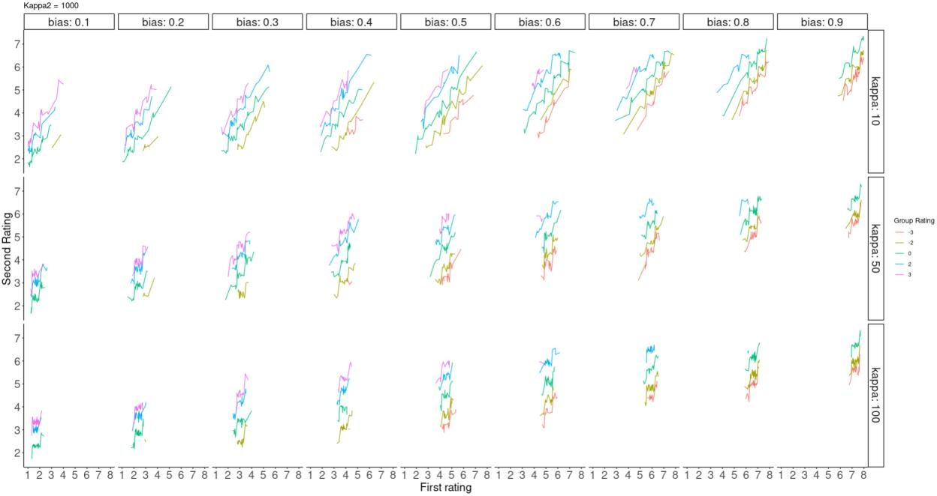

Looking at inverting this model using stan, we saw that the bias term was generally well recovered with 100 trials, however we did not do a complete parameter recovery analysis. See plot below for a couple of agents that with known values, where the blue histogram is the posterior distribution for the parameter and the red the prior. One can generally see that the model seems to underestimate the bias term with these configurations of kappa, kappa2 and trials.

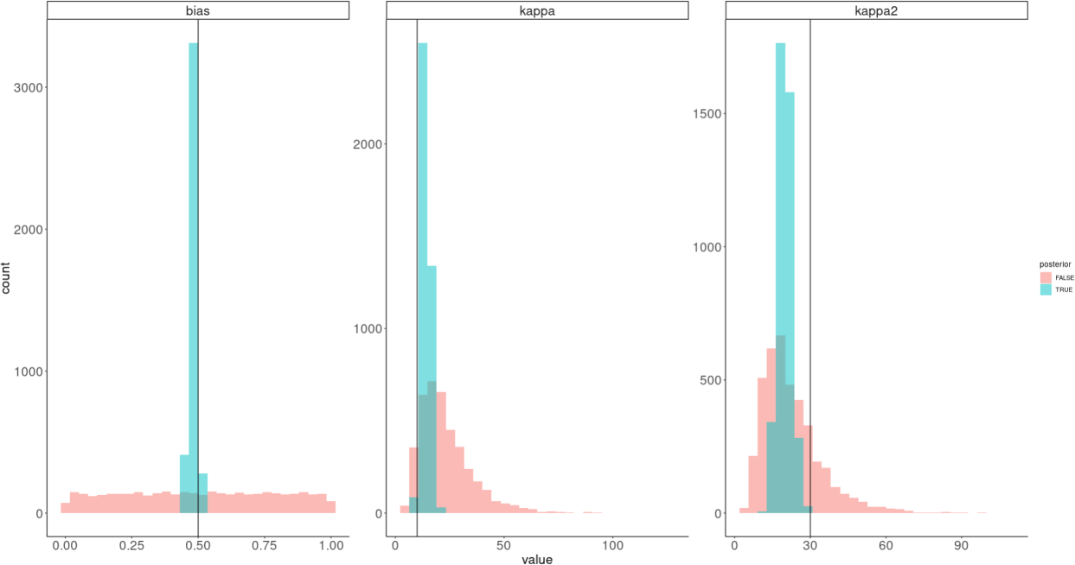

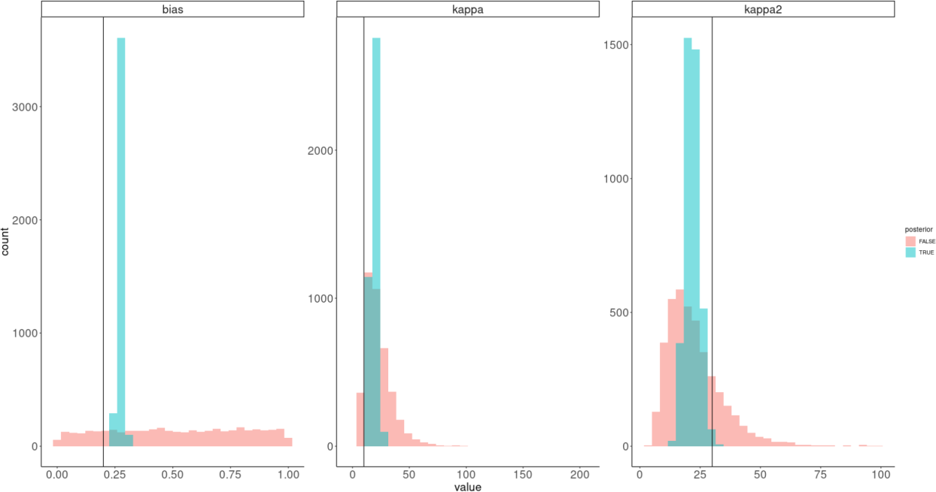

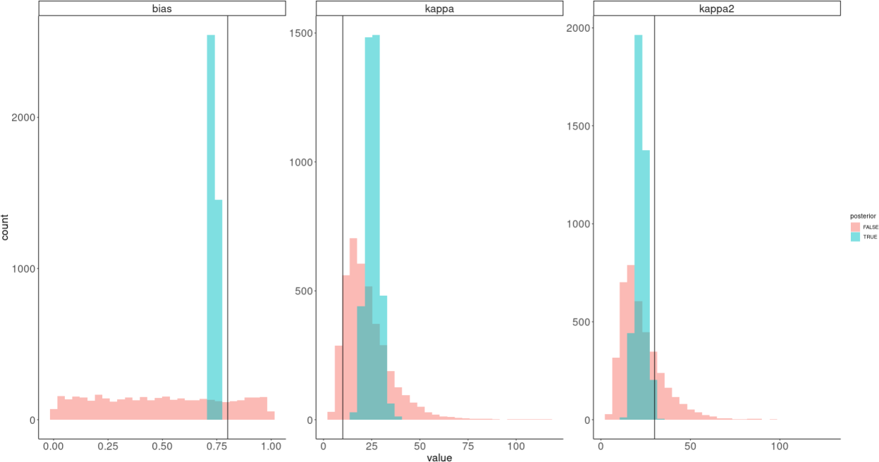

We also looked at simulated vs inferred second ratings of the participants here shown for the configurations (bias = 0.8, kappa = 10, kappa2 = 30)

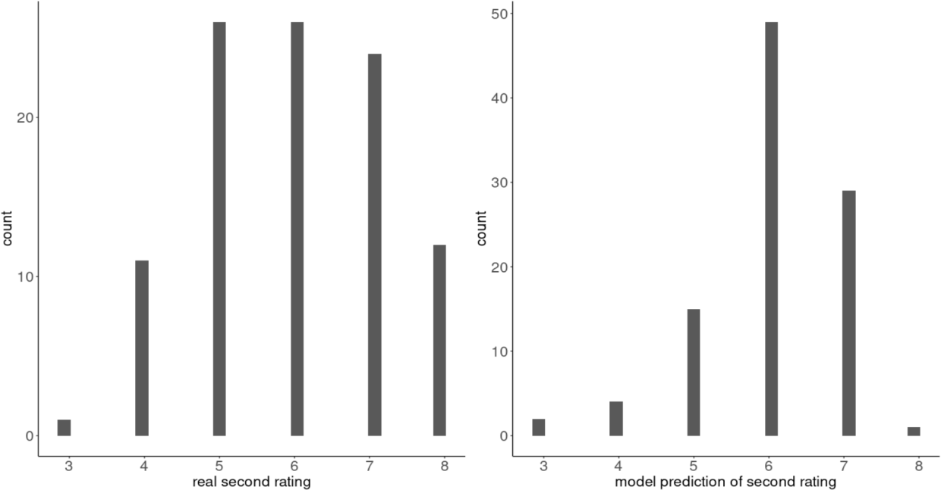

# Hierarchical Simple bayes:

Here we simulate 10 agents based on the following hierarchical parameters:

𝑏𝑖𝑎𝑠 ~ 𝐵𝑒𝑡𝑎(0.8,10)

𝐾𝑎𝑝𝑝𝑎1 ~ 𝐿𝑜𝑔𝑛𝑜𝑟𝑚𝑎𝑙(0.5, 3)

𝐾𝑎𝑝𝑝𝑎2 ~ 𝐿𝑜𝑔𝑛𝑜𝑟𝑚𝑎𝑙(0.5, 3)

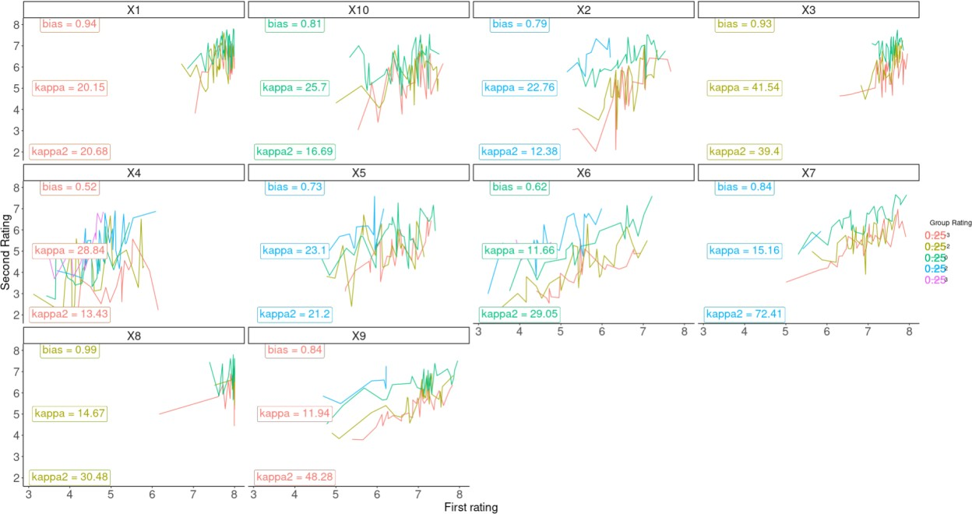

Inverting this model in stan also produced decent results, again without during full parameter recovery:

First the group level estimates:

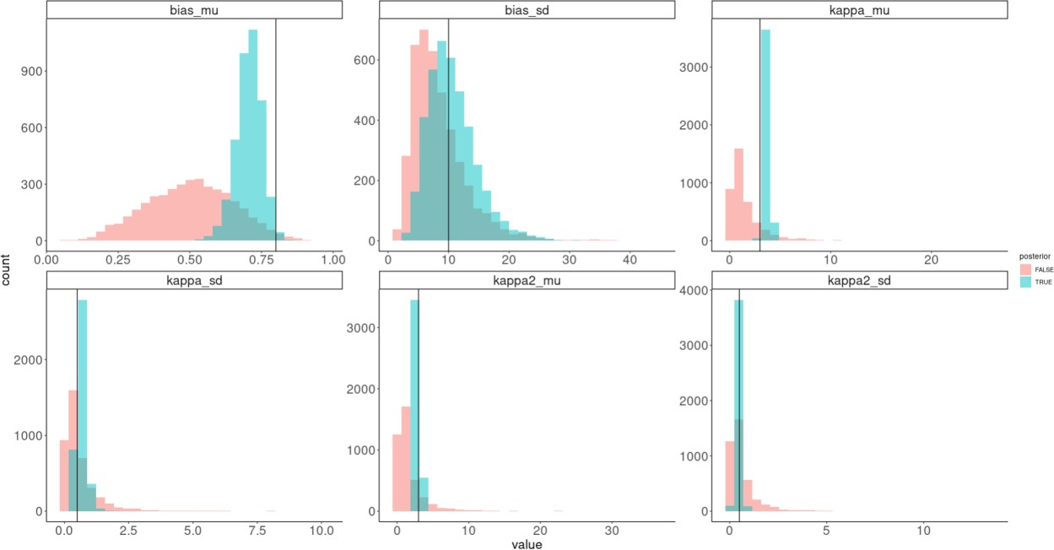

And then the subject specific parameters: Here the first row is the bias parameter the second row the kappa parameter and the third row the kappa2 parameter

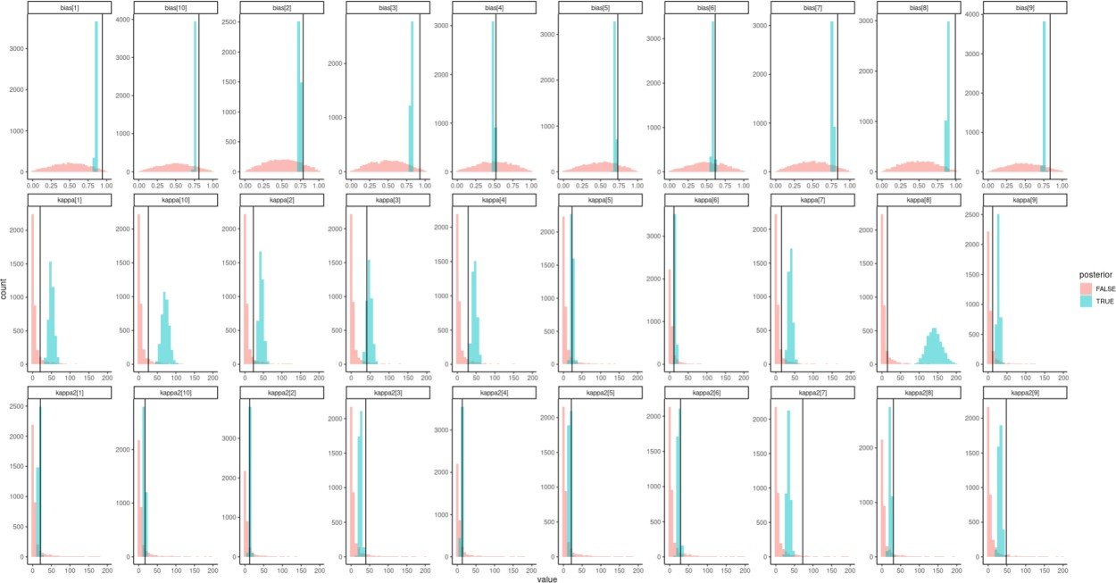

Here we also looked at how well the chains mixed and whether there was any reason for using a non- centered parameterization (i.e. looking for funnels).

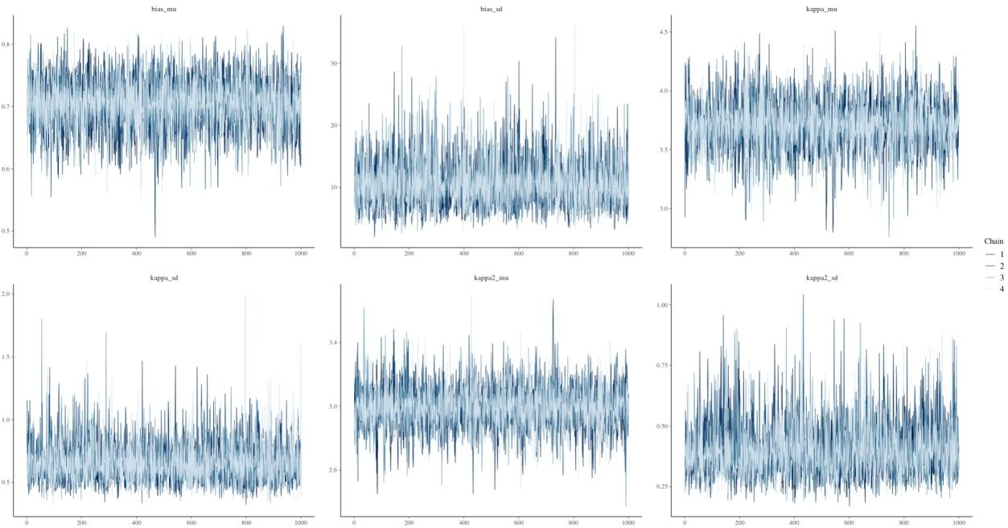

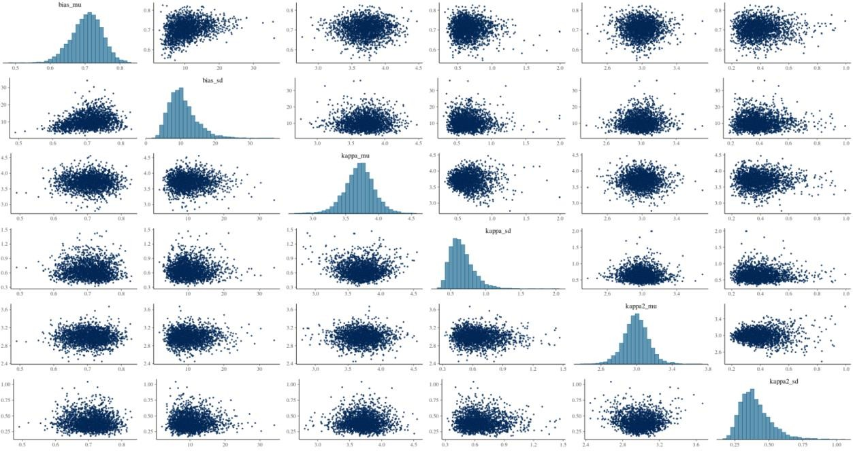

As can be seen the chains mix well and there seems to be no reason to implement the non-centered parameterization at least with these parameter values.

Lastly we looked at the posterior predictive check, here real is the simulated agents responses and pred being the predicted responses based on the model:

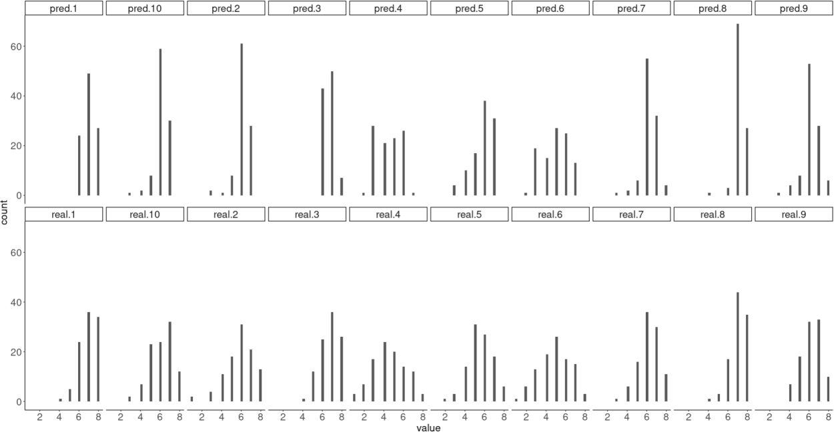

# Weighted bayes



Here we show the how the different weights influence the ratings of the agent here with bias = 0.5, kappa = 10 and kappa2 = 100.

We then invert this model and see how well these weights with the other parameters can be recovered (without the full parameter recovery analysis)

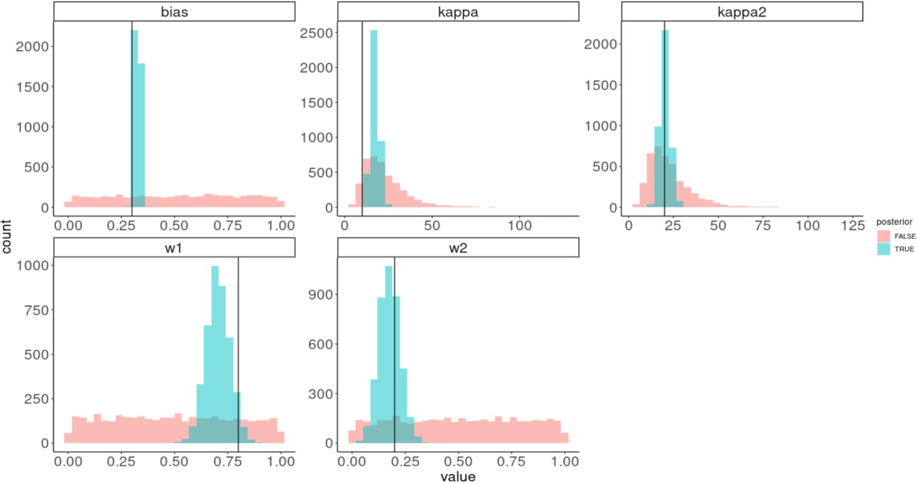

Next we implemented the weighted hierarchical bayes where we used the non-centered parameterization as the centered produced many divergent chains:

We start off by simulating 10 agents 100 trials with the following hierarchical parameters:

𝑊1 ~ 𝐵𝑒𝑡𝑎(0.2,10)

𝑊2 ~ 𝐵𝑒𝑡𝑎(0.8,10)

𝑏𝑖𝑎𝑠 ~ 𝐵𝑒𝑡𝑎(0.5,10)

𝐾𝑎𝑝𝑝𝑎1 ~ 𝐿𝑜𝑔𝑛𝑜𝑟𝑚𝑎𝑙(0.5, 3)

𝐾𝑎𝑝𝑝𝑎2 ~ 𝐿𝑜𝑔𝑛𝑜𝑟𝑚𝑎𝑙(0.5, 3)

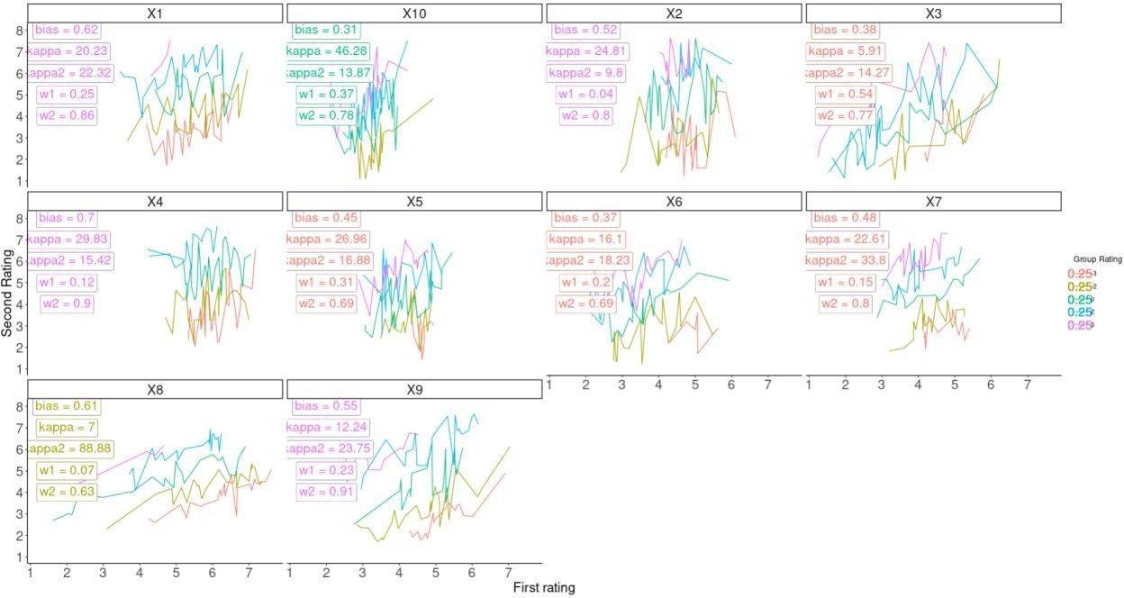

We then fit this data to the model and look at the recovered hierarchical parameters:

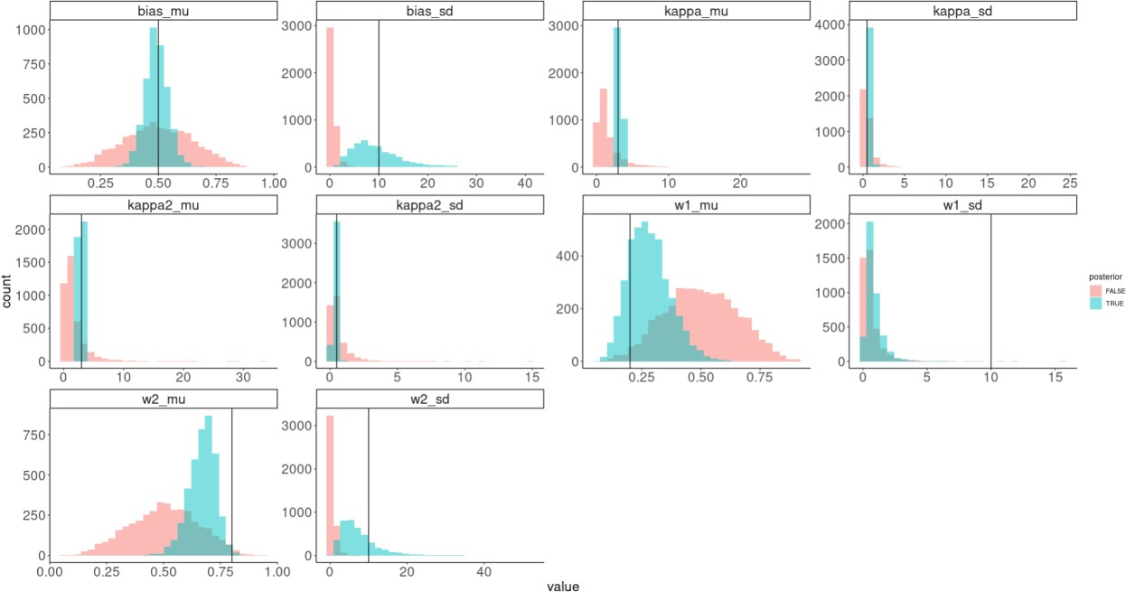

The chains seemed to mix well:

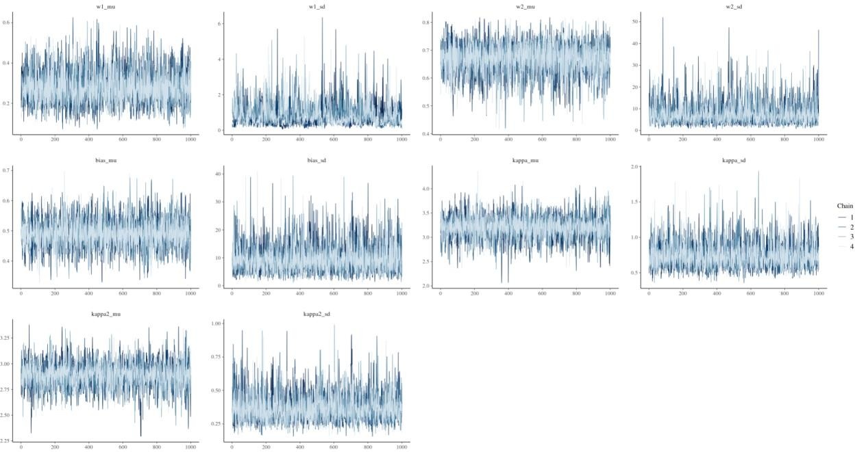

Looking at the subject specific parameters we see that these are also decently recovered (priors could need a bit of help here):

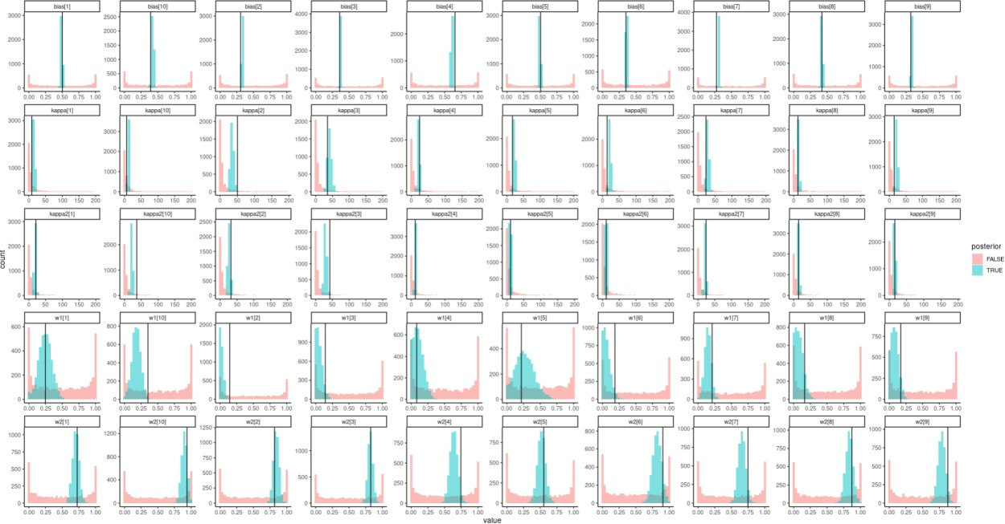

# Fitting the models to the data

Now we fit these models to the actual data. This data includes 44 Cognitive science students before the pandemic that went through 80 trials of the experiment. Here we fit the data too both

hierarchical models and test which of the models describe the data the best. First looking at the chains:

Simple bayes:

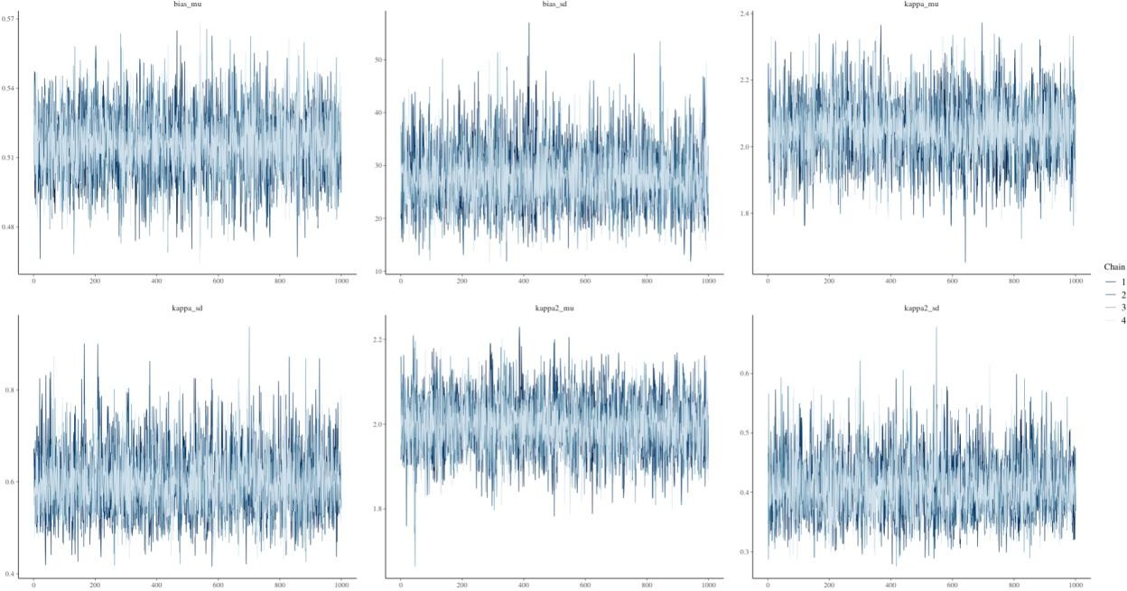

Weighted bayes:

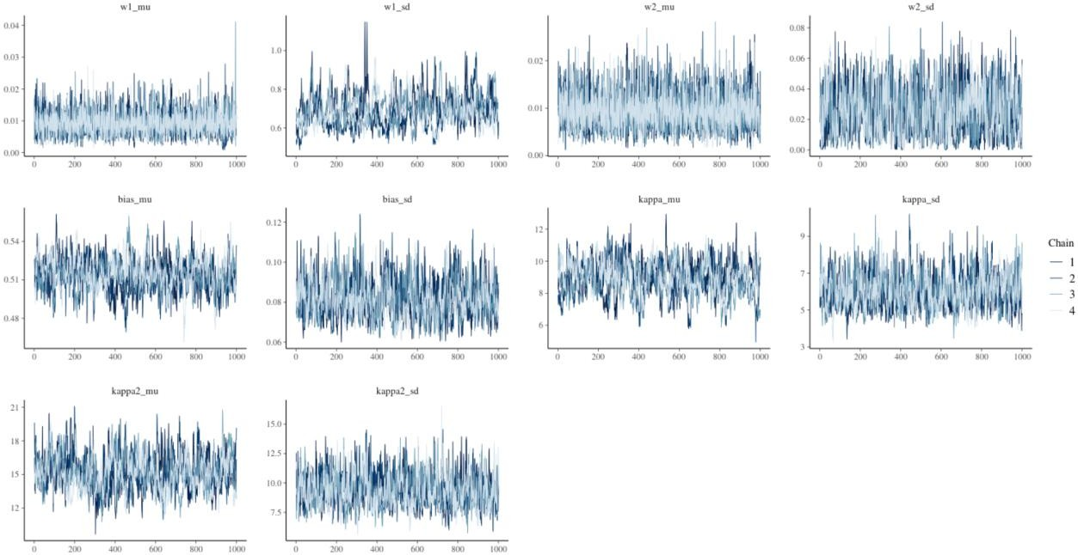

After confirming no divergent chains and that the chains mixed well we calculated the expected log pointwise predictive density (elpd) leave one out (loo) to access model comparison. Here we first

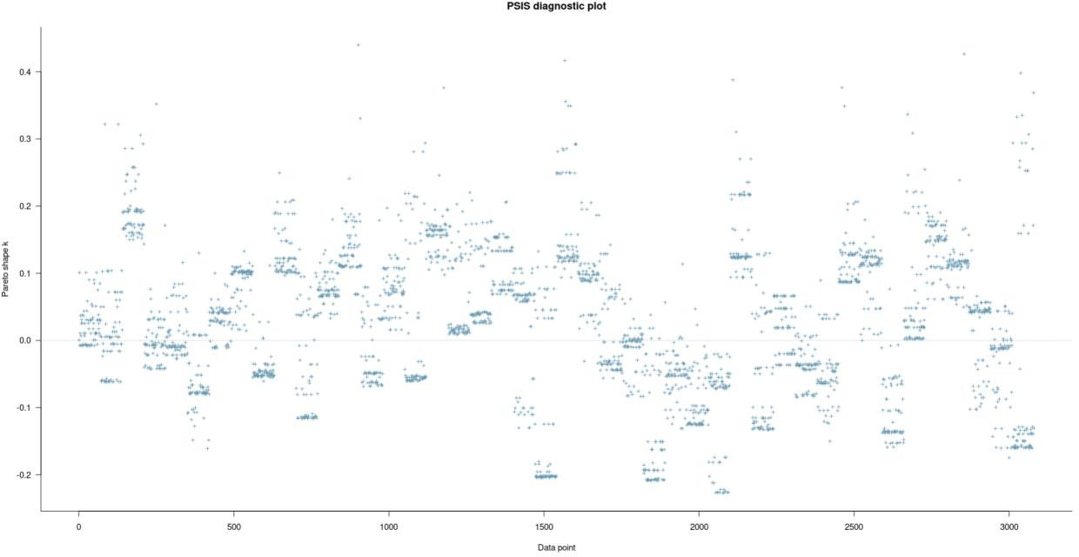looked at the pareto shape k to see if there was any influential datapoints: Simple bayes:

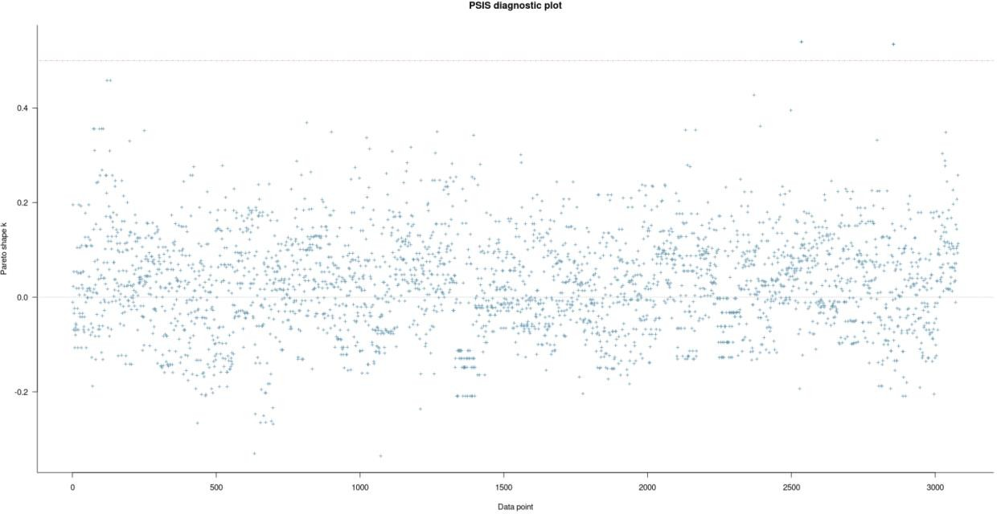

Next we plotted the elpd difference between the two models:

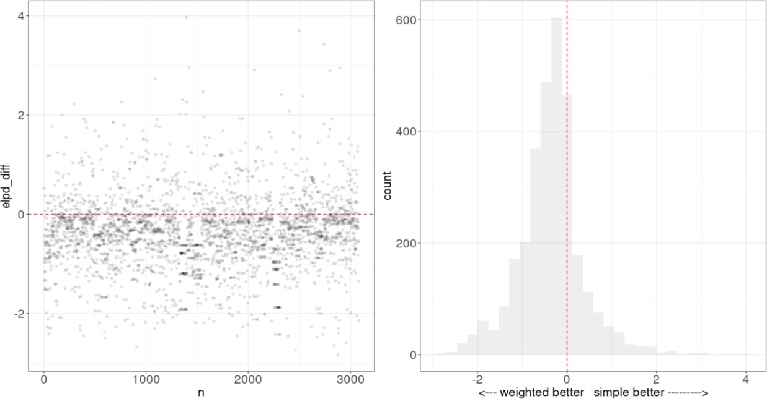

Showing that the weighted model was superior for most data points.

Lastly we mean and standard error of the difference and accessed the model weights with the loo package.

Again confirming that the weighted bayes model predicts the data the best with the weighted bayes getting a model weight of 1.

|  |  |  |
| --- | --- | --- |
|  | Elpd_diff | Elpd_se |
| Weighted bayes | 0.0 | 0.0 |
| Simple bayes | -1097.4 | 40.0 |